**Mini Project Report on**

**“IOT BASED SMART PARKING”**

**Group Members**

Nandini Sharma (501654)

Aadya Singh (501658)

Sneha Singh (501659)



**Department of Information Technology**

**Fr. Conceicao Rodrigues Institute of Technology**

Sector 9A, Vashi, Navi Mumbai – 400703

University of Mumbai

2018-2019

**CERTIFICATE**

This is to certify that the project entitled

**IOT Based Smart Parking**

**Submitted By**

Sneha Singh

Aadya Singh

Nandini Sharma

In partial fulfillment of degree ofT.E in **Information Technology** for term work of the project is approved.

**External Examiner Internal Examiner**

**________________ ________________**

**Head of Department Internal Guide**

**___________________ ___________________**

**Date : 29 October,2018**

**Abstract**

Mumbai being a metropolitan city, parking becomes a huge issue due to growing population, industrialization of the world and mismanagement of the available parking space. Finding a parking becomes tedious and time-consuming especially at prime locations. Long waiting time, unpredictable availabilities and high fares aggravate the situation.

Many car slot management systems have been employed to reduce the congestion of traffic and prove to be efficient for the vehicle drivers.

 Our project aims at easing the customer’s experience by providing them a means by which this can be resolved to an extent. The aim of this project is to inform users about the availability of parking slots which will help the user to locate free parking spaces. We also provide fare calculation which is being displayed at the admin end.

i

**TABLE OF CONTENTS**

ii

|  |  |  |
| --- | --- | --- |
| Sr. No | Topic | Page No |
|  | Abstract | i |
|  | List of Figures | iv |
|  | List of Tables | iv |
| 1 | Introduction   * 1. Background   2. Motivation/need/purpose   3. Problem Definition   4. Scope   5. Proposed System Features   6. Objectives   7. Issues/Limitations | 1 |
| 2 | Literature Survey  2.1 Related Work  2.2 Existing System | 5 |
| 3 | System Design  3.1 Architecture Design  3.2 Flow Chart | 9 |
| 4 | System Requirements  4.1 Hardware Requirements  4.2 Software Requirements | 13 |
| 5 | Implementation Details  5.1 User Interface  5.2 Algorithm | 15 |
| 6 | Experimental Results | 19 |
| 7 | Conclusion/Future Scope  7.1 Conclusion  7.2 Future Scope | 22 |
| 8 | Appendix: Code Sample | 24 |
| 9 | References | 28 |
| 10 | Acknowledgement | 30 |

iii

**LIST OF FIGURES**

|  |  |  |
| --- | --- | --- |
| **Fig. No.** | **Figure Name** | **Page No.** |
| 3.1 | Architecture Design for Connection with Ultrasonic Sensor | 10 |
| 3.2 | Connection of LED with Breadboard | 11 |
| 5.1 | Initial state of Parking Zone before car enter | 16 |
|  |  |  |
|  |  |  |
| 5.2 | Before car enters the parking slot, LED is off to show availability | 16 |
| 5.3 | When car enters slot, it gets occupied and LED glows to denote unavailability of that slot | 17 |
| 5.4 | When car exits slot, LED stops glowing and thus spot becomes available again | 17 |
| 6.1 | Initial state of Parking Zone before car enters | 20 |
| 6.2 | Before car enters the parking slot, it displays “empty” to show availability | 20 |
| 6.3 | When car enters slot, it display “occupied” to denote unavailability of that slot | 20 |
| 6.4 | When car exits slot, it calculates fare and displays | 21 |

**LIST OF TABLES**

|  |  |  |
| --- | --- | --- |
| **Table. No.** | **Table Name** | **Page No.** |
|  |  |  |
| 2.1 | Summary of the Existing Systems | 8 |

iv

**CHAPTER 1**

**INTRODUCTION**

1

**1 INTRODUCTION**

**1.1 BACKGROUND**

A growing trend in computing is the “Internet of Things” - objects or devices connected to the Internet that can gather, process, and share data. These are also called as smart devices programmed to process data and respond automatically to certain conditions. They have inputs, such as sensors, that gather data from the physical environment and/or outputs, such as actuators. Smart devices also send and/or receive data by communicating with apps, databases, or other devices through a network connection.

The Internet of Things has become possible due to advances in technology and manufacturing. Computing part have become much smaller, more powerful, more energy-efficient, and less expensive. Wireless networking has become much faster, more energy-efficient, and more widespread. These advances have made it feasible to incorporate computing technology into almost any object, device, or environment.

* 1. **MOTIVATION / NEED / PURPOSE**

Car parking is a major issue in modern congested cities of today. Being residents of Mumbai a city which is at its peak 24 hours, finding an empty parking slot is a tedious and time consuming task. There simply are too many vehicles on the road and not enough parking space. This has led to the need for efficient parking management systems which brings us to our topic. Thus we demonstrate the use of IOT based parking management system that allows for efficient parking space utilization.

2

**1.3 PROBLEM DEFINITION**

There has been a sudden outburst in population growth and immigrants to metropolitan cities in recent times. This has come along with raised lifestyle standards where having at least one car per family has become a common scenario. This has lead to huge number of cars on roads which not only is causing traffic but also creating a huge problem of parking especially at prime locations. The unpredictability of free parking slots has created an issue common at

almost every location in cities like Mumbai. This has created a need for an efficient solution to manage parking spot availability.

**1.4 SCOPE**

Currently most of the existing car parking systems are manually managed and a little inefficient. In urban areas, number of vehicles is higher as compared to the availability of parking spaces. Our system will manage the parking slot availability and will inform the user if slots are vacant or full. Also depending on how long a user used a particular slot our system calculates the fare. Hence we try and provide a digital platform for the same which reduces manual intervention and is preferred by the customers.

* 1. **PROPOSED SYSTEM FEATURES**

1. Our system uses ultrasonic sensors to sense the presence of cars in the parking slots.

2. Inform the user about the availability of a particular slot.

3. Check for the availability of slots every 5 seconds.

4. Calculate the fare depending on how long a car was parked in the slot.

* 1. **OBJECTIVES**

1. Automate the car parking system to manage cars parked at various prime locations.

2. Regulate the traffic flow by providing prior knowledge regarding the empty parking slots.

3. Provide knowledge regarding the fare and digitize the transactions.

3

**1.7 ISSUES/LIMITATIONS**

Ultrasonic sensors are capable of sensing all the metallic bodies within its arena. Any metallic body that is sensed within the sensing range will consider the parking slot as booked, even when there wont be any new car entrant. Hence, to overcome this, car plate reader needs to be implemented alongside as well.

The sensing range of ultrasonic sensors is limited to 10 meters. Hence when deployed in real world, a lot many sensors might be needed to be installed in each parking region.

The project does not provide the fare calculation to be displayed at the user’s end as of now. This drawback can be overcome in future by integrating it with an android application.

4

4

**CHAPTER 2**

**LITERATURE SURVEY**

5

**2 LITERATURE SURVEY**

**2.1 EXISTING SYSTEM**

**[A] Expert systems**

Expert Systems or Agent based technologies can solve the problems associated with distributed and complex traffic environment. Multi-Agent system is a modelling technique. It is used for representation of system with elements which show intelligence, autonomy, and degree of interaction either with each other or with environment.

Mobile agents can move within the nodes of a network and are made dynamically during the runtime. They are sent to destination systems for performing different tasks with the up to date code and algorithm. Mobile agents also result in reduction of data transmission over the networks.

These systems do not provide the best possible parking facility as they do not take the parking fee into consideration. In the absence of the negotiation on the parking fee, the consumers loose the opportunity of finding a cheaper and better parking place.

**[B] Fuzzy logic based systems**

Fuzzy theory is used for building the support knowledge and heuristics of the high-level expert human. The method discussed gives a car the capability to independently drive on different types of roads. It also envisions movements like reverse, parallel parking and three point turns. For automatically getting a functioning car control system, this approach uses a self-training system which benefits from human skills.

The system works by

A] Detecting

B] Motion Planning, and

C] Supplying information

**[C] Wireless sensor based systems**

A number of low cost sensor nodes make up a Wireless Sensor Network (WSN). They arrange themselves for making an ad hoc network through the wireless communication module present on nodes.

6

These systems are not architected for car parking management, though they are effective for checking traffic and road condition. The used hardware in these systems is also expensive and complex. For accurate and reliable detection of vehicles in parking facility, the use of magnetic and ultrasonic sensors is proposed.

**[D] GPS based systems**

The information about the location and availability of a parking space near the destination is provided to the drivers by the current GPS-based vehicle navigation system. The information of the current state of the parking facility is provided. That’s why they can’t guarantee a parking lot when the driver reaches the facility. This system helps in locating the parking lots on campus or areas like airports, but it doesn’t provide any information about the availability of vacancy.

**[E] Vehicular communication systems**

It proposes a new smart parking technique based on vehicular communication for large parking lots. This scheme provides the real-time parking navigation service, intelligent antitheft protection, and friendly parking information dissemination to the driver. It makes the following contributions.

a). It provides real time parking navigation to the drivers for finding the vacant parking space, saving fuel and time.

b) It provides VANET-based intelligent anti-theft protection. Due to this, all the parked cars at the parking facility are guarded by the parking facility’s RSUs. Any car which tries to leave the parking facility illegally will be detected by the RSU.

c)It arranges friendly parking information distribution service to all the mobile cars.

**[F] Vision based systems**

The parking control and revenue system in big cities are relying on devices such as coins or token based parking meters, which requires exact change and man power for monitoring the parking lots, making it unfavourable. So a more efficient design for automated parking meter and driver assistance is presented. Every car has a unique Vehicle Identification Number (VID) associated with it. For overcoming the common discrepancies of the existing vision based target parking position labelled methods in dark indoor parking sites, it proposes a light stripe projection based free parking space recognition method. For recognition of the 3D information of parking site, light stripe projection method is also used.

7

Table 2.1 Summary of the existing systems

| **S. No.** | **Different Technologies** | **Features** | **Services Provided** |
| --- | --- | --- | --- |
| **1.** | Agent Based | Dynamic Distribution and Complex Traffic Environments | Bargaining, parking guidance and route negotiation etc. |
| **2.** | Fuzzy Based | Human-like intelligence and expertise | Intelligent parking methods e.g. parallel parking and perpendicular parking etc. |
| **3.** | Wireless Sensor Based | Low cost implementation with lower power consumption | Detection and monitoring of the parking facility etc. |
| **4.** | GPS Based | Real time location based information and guidance towards destination | Provides information about the locality and availability of parking facility |
| **5.** | Vehicular Communication | Provision of parking information distribution service for mobile vehicles | Antitheft protection, real time parking navigation service etc. |
| **6.** | Vision Based | Good for car searching in large parking lots | Lot occupancy detection, parking space recognition, parking charges collection etc. |

**As referenced from the technical paper:**

Technical Paper “A Survey of Intelligent Car parking system” by Faheem, S.A.Mahmud, G.M Khan, M.Rahman and H Zafar

8

**CHAPTER 3**

**SYSTEM DESIGN**

9

**3 SYSTEM DESIGN**

**3.1 ARCHITECTURE DESIGN**

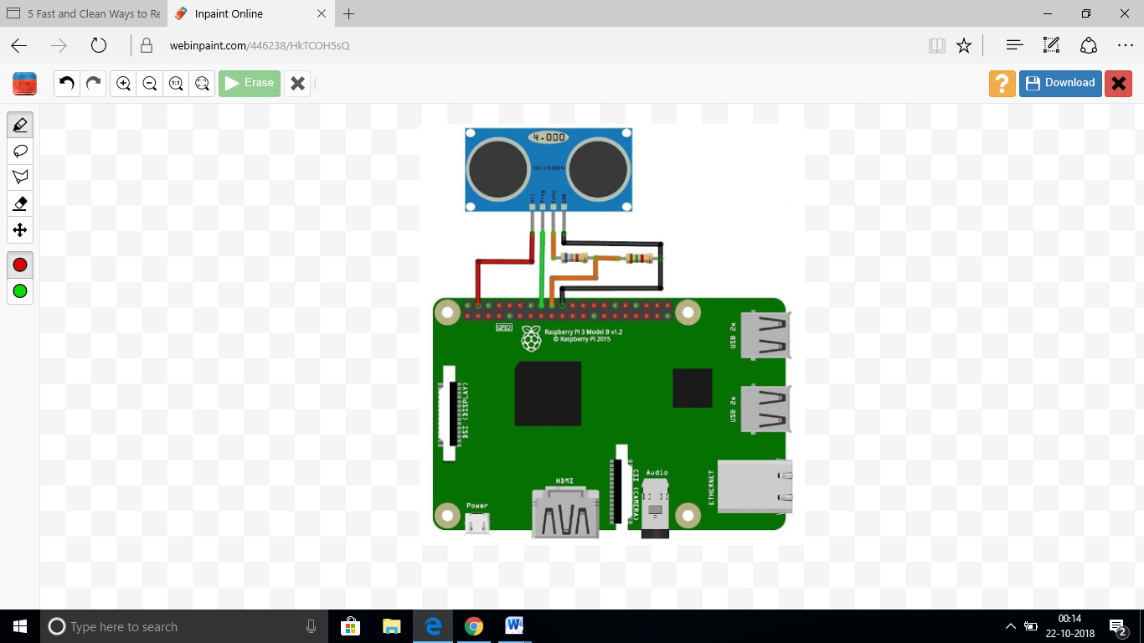

Fig 3.1 Architecture Design for Connection with Ultrasonic Sensor

10

**CONNECTION OF LED WITH BREADBOARD:**

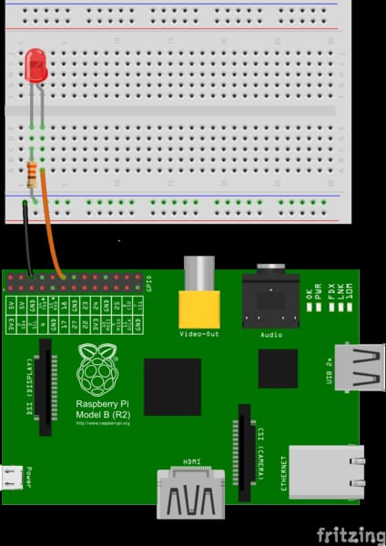

Fig 3.2 Connection of LED with Breadboard

11

10

**3.2 FLOWCHART**

(A)The triggering of the ultrasonic sensor

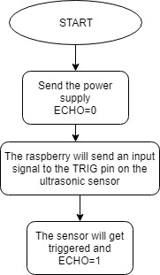

(B) The distance calculation strategy:

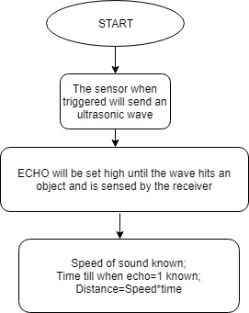

12

**CHAPTER 4**

**SYSTEM REQUIREMENTS**

13

12

**4 SYSTEM REQUIREMENTS**

**4.1 HARDWARE**

* Raspberry kit
* LED
* Ultrasonic sensor HC-SR04
* 1kΩ resistor
* 2kΩresistor
* Jumper wires
* Breadboard

**4.2 SOFTWARE**

* NOOBS

13

* VNC server and VNC Viewer
* Python IDE

14

**CHAPTER 5**

**IMPLEMENTATION DETAILS**

15

**5 IMPLEMENTATION DETAILS**

**5.1 USER INTERFACE**

**A. Initial State:**

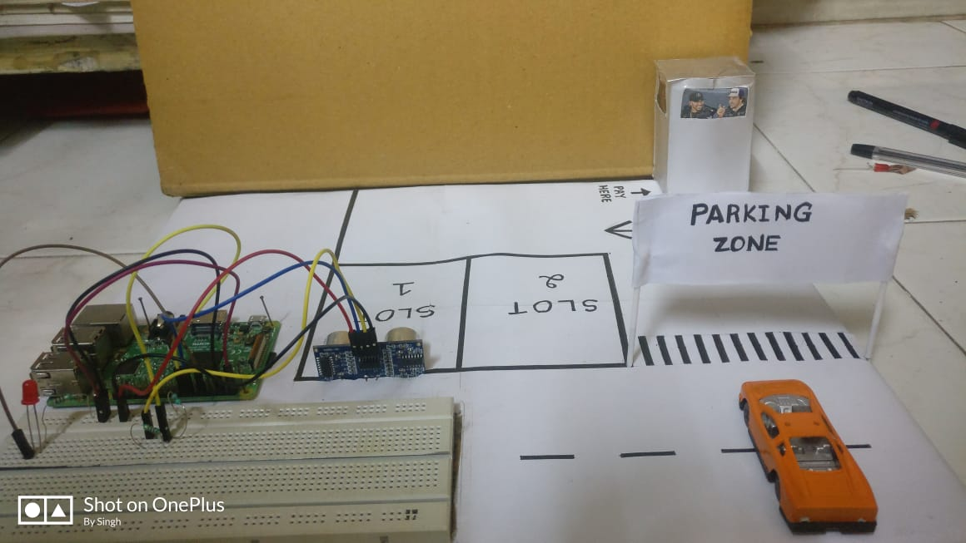

Fig 5.1: Initial state of Parking Zone before car enters

**B. Before car enters the parking slot**

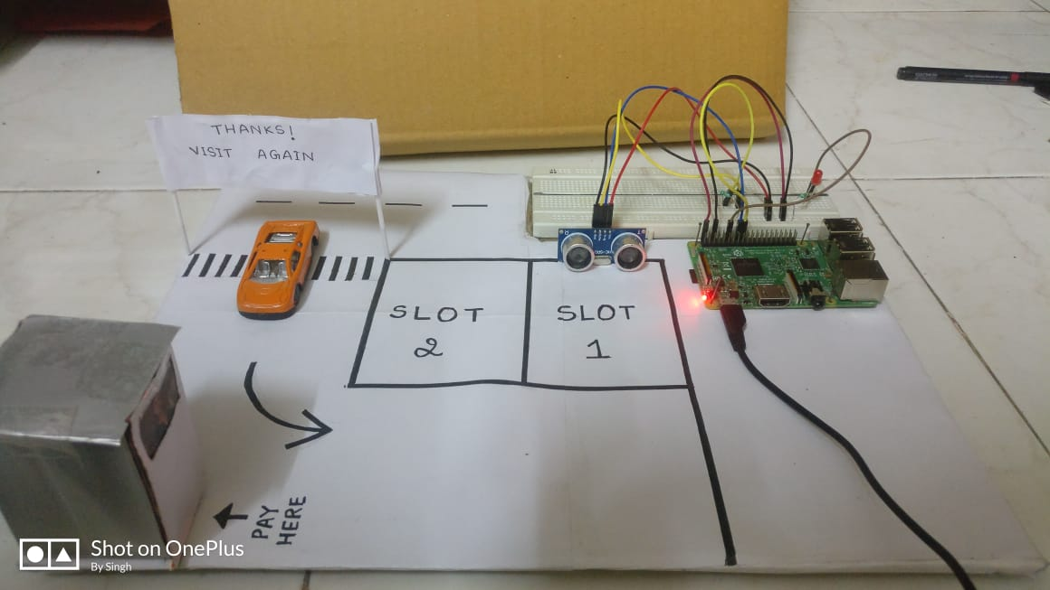

Fig 5.2: Before car enters the parking slot, LED is off to show availability

16

**C. When Car occupies parking slot:**

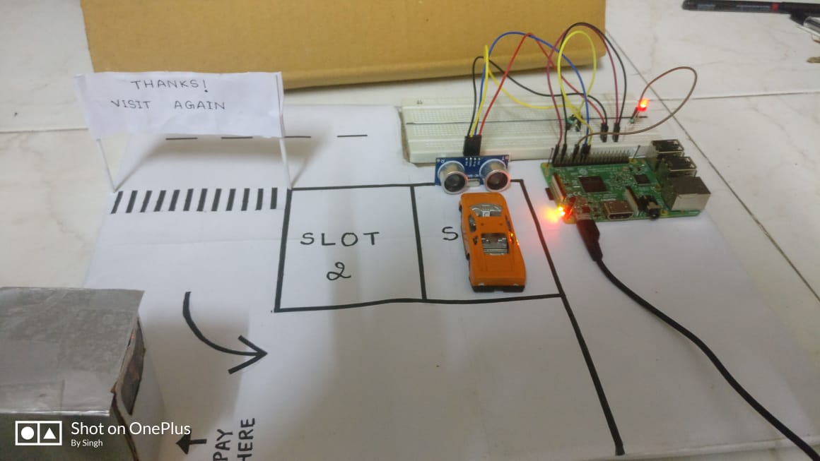

Fig 5.3: When car enters slot, it gets occupied and LED glows to denote unavailability of that slot

**D. When Car exits parking slot:**

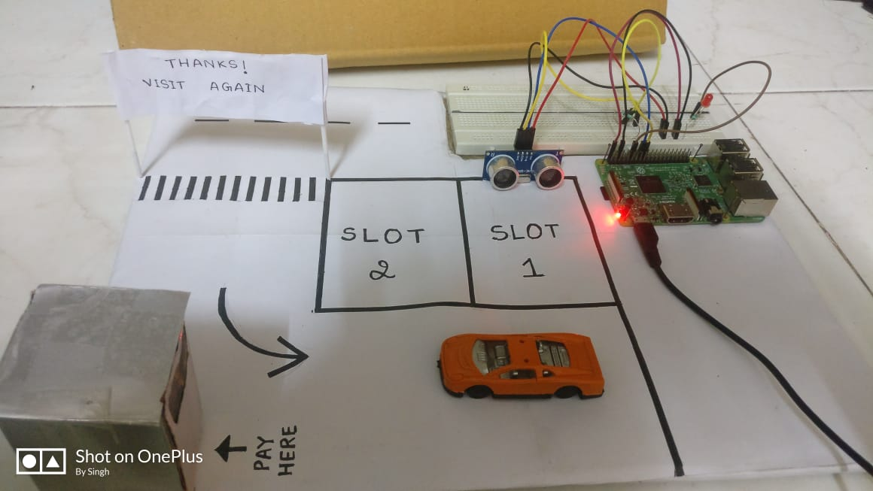

Fig 5.3: When car exits slot, LED stops glowing and thus spot becomes available again

17

**5.2 Algorithm**

1) Start

2) The raspberry kit triggers the sensor on the TRIG pin.

3) The ECHO pin set to disabled gets high.

4) The ultrasonic sensor sends the wave and waits for receiving the reflected wave.

5) The distance hence can be calculated.

6) While true:

i) Send the wave

ii) If distance<7 and unoccupied slot:

Print occupied and start the timer.(timer_start=current time)

Else:

Print unoccupied.

iii) Repeat step 6i again.

If again car slot is occupied, do nothing.

Else

Calculate the time difference from the current time and the timer_start variable.

18

**CHAPTER 6**

**EXPERIMENTAL RESULTS**

19

16

**6 EXPERIMENTAL RESULTS**

**A. Initial State:**

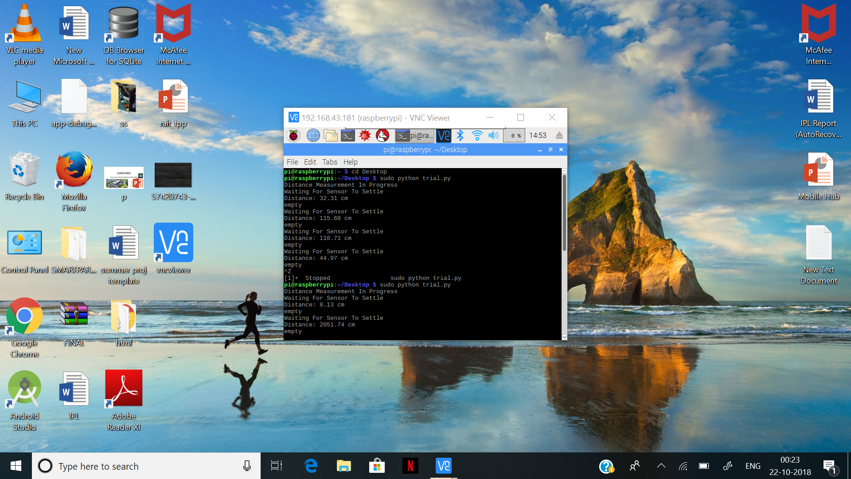

Fig 6.1: Initial state of Parking Zone before car enters

**B. Before car enters the parking slot**

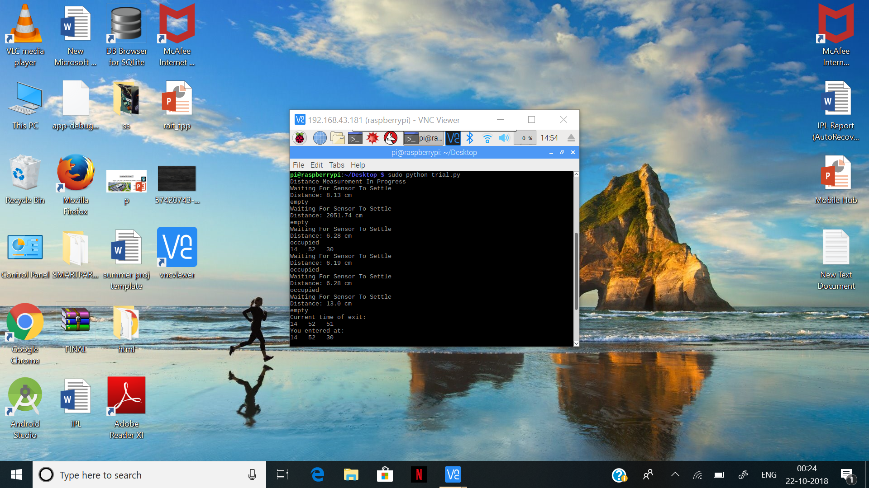

Fig 6.2: Before car enters the parking slot, it displays “empty” to show availability

**C. When Car occupies parking slot:**



Fig 6.3: When car enters slot, it display “occupied” to denote unavailability of that slot

20

**D. When Car exits parking slot:**

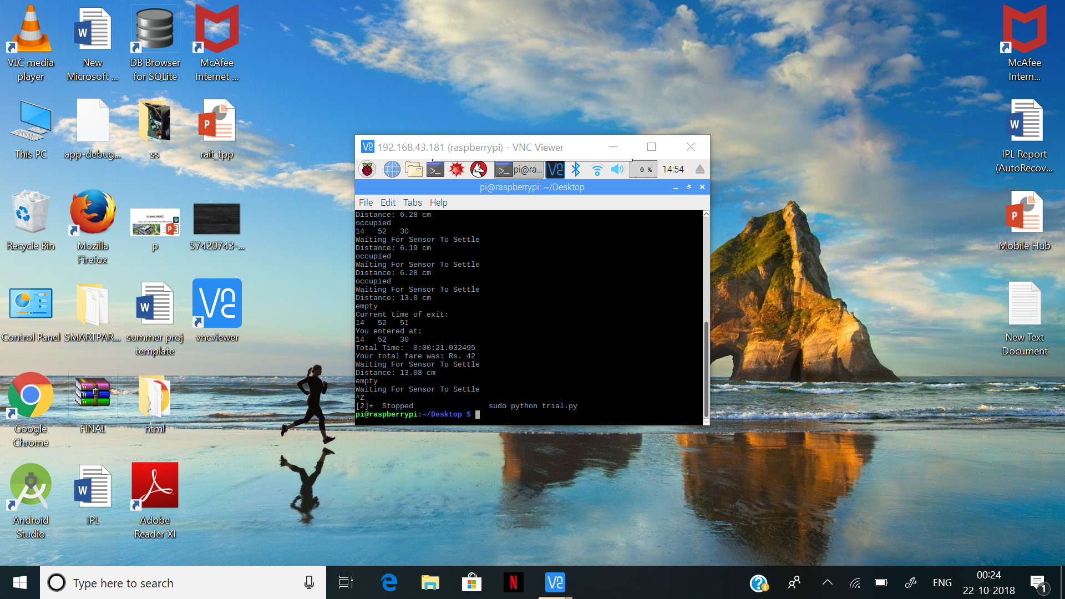

Fig 6.4: When car exits slot, it calculates fare and displays

21

**CHAPTER 7**

**CONCLUSION/FUTURE SCOPE**

22

18

**7 CONCLUSION/FUTURE SCOPE**

**7.1 CONCLUSION**

We have successfully implemented our IoT project that demonstrates the availability of free parking slots by using ultrasonic sensors which detect the presence of cars in the slots. We indicate the availability by making use of LEDs. Also the fare is being calculated which is directly proportional to the amount of time a particular slot was in use. This fare is displayed at the admin end.

**7.2 FUTURE SCOPE**

In future, we plan to extend our project by integrating it along with an android application that would display the fare directly at the user’s account. Also in order to avoid sensing any metallic element other than a car and considering the slot as booked, we plan to execute image processing that would scan the car plate number and only then would the slot be considered as reserved.

We also aim to implement buzzers if a user tries to empty the parking region without any payment.

23

**CHAPTER 8**

**APPENDIX: CODE SAMPLE**

24

20

**8 APPENDIX: CODE SAMPLE**

import RPi.GPIO as GPIO

import time

import datetime

GPIO.setmode(GPIO.BCM)

GPIO.setwarnings(False)

GPIO.setup(18,GPIO.OUT)

GPIO.setmode(GPIO.BCM)

TRIG = 23

ECHO = 24

occupied = False

flag=0

timer=0

i=0

print "Distance Measurement In Progress"

GPIO.setup(TRIG,GPIO.OUT)

GPIO.setup(ECHO,[GPIO.IN](http://gpio.in/))

GPIO.output(TRIG, False)

def stime(s_now):

    global timer

    if(timer==0):

        timer=1

        GPIO.output(18,GPIO.HIGH)

        s_now=datetime.datetime.now()

        print s_now.hour," ",s_now.minute," ",s_now.second

    return s_now

def etime(s_now):

254

    global timer

    if(timer==1):

        timer=0

        GPIO.output(18,GPIO.LOW)

        e_now=datetime.datetime.now()

        print e_now.hour," ",e_now.minute," ",e_now.second

        print "Timer started at"

        print s_now.hour," ",s_now.minute," ",s_now.second

        diff=e_now-s_now

print diff.seconds

def cald(t):

    pulse_start=0

    pulse_end=0

    print "Waiting For Sensor To Settle"

    time.sleep(2)

    GPIO.output(TRIG, True)

    time.sleep(0.00001)

    GPIO.output(TRIG, False)

    while GPIO.input(ECHO)==0:

      pulse_start = time.time()

    while GPIO.input(ECHO)==1:

      pulse_end = time.time()

    pulse_duration = pulse_end - pulse_start

    distance = pulse_duration * 17150

    distance = round(distance, 2)

    print "Distance:",distance,"cm"

    if (distance < 7):

         print "occupied"

         pulse_start=0

         pulse_end=0

26

         flag=1

         timecatch=stime(t)

         return timecatch

    else:

         print"empty"

         pulse_start=0

         pulse_end=0

         flag=0

         etime(t)

while True:

  if(i==0):

     t=datetime.datetime.now()

     i=i+1

  print t

  t=cald(t)

  time.sleep(5)

GPIO.cleanup()

27

**CHAPTER 9**

**REFERENCES**

28

22

**9 REFERENCES**

* Technical Paper “A Survey of Intelligent Car parking system” by Faheem, S.A.Mahmud, G.M Khan, M.Rahman and H Zafar
* FOR NOOBS INSTALLATION:

https://www.raspberrypi.org/downloads/noobs/

* FOR SETTING UP VNC SERVER AND VNC VIEWER:

23

https://www.realvnc.com/en/connect/docs/get-connected.html

* https://circuitdigest.com/microcontroller-projects/raspberry-pi-distance-measurement-using-ultrasonic-sensor

29

**CHAPTER 10**

**ACKNOWLEDGEMENT**

30

**10 ACKNOWLEDGEMENT**

We would like to express our heartfelt gratitude to our college Fr.Conceicao Rodrigues Institute of Technology for giving us an opportunity to undertake this project. We are grateful to Mr Suraj Khandare for giving us a chance to work on this project in our course of Engineering. We are thankful to, and fortunate enough to get constant encouragement, support and guidance from all our teachers of IT Department which helped us in successfully completing our project. We also thank our HOD Dr. H. K. Chavan for giving us this opportunity to implement this project.

We would also like to extend our gratitude to our parents for their support throughout, and the constant efforts and motivation by our teammates and friends which helped us attain successful completion of this project.

31

31